
Assessment Cover Page
Student Full Name | Daniella Silveira e Silva
Student Number | 2026613
Module Title | Machine Learning
Assessment Title | CA1 – Predicting Maternal Health Risk during Pregnancy
Lecturer/Supervisor | Dr. Muhammad Iqbal
Assessment Due Date | Sunday 15th November 2026 @ 23:59 (IST)
Date of Submission | Wednesday 12th November 2026
GitHub Link | https://github.com/Daniella-CCT/Machine-Learning-Sept26
Google Drive Link (If required) | Not required

Predicting Maternal Health Risk during Pregnancy with Random Forest and Support Vector Machines

1. Introduction and Motivation
In 2023, about 260,000 women died from complications of pregnancy and childbirth, and most of these deaths were preventable. High blood pressure is one of the main causes (WHO, 2025). In rural areas with limited access to doctors, a tool based on simple vital signs could help identify high-risk pregnancies early.
This project uses the Maternal Health Risk dataset (Ahmed, 2020), collected in rural Bangladesh through an IoT-based monitoring system (Ahmed et al., 2020). The risk level (low, mid or high) is a category, so this is a supervised multi-class classification problem. Machine learning can combine several vital signs and learn non-linear patterns that simple rules may miss. Three questions guided the project:
- Which features are the most important for predicting the risk level?
- Which classifier is more suitable, Random Forest or Support Vector Machine (SVM), and why?
- How do the test split size and hyperparameter tuning affect accuracy and generalisation?
The work followed CRISP-DM (Larose and Larose, 2014) using Python and scikit-learn (Pedregosa et al., 2011).

2. Data, Pre-processing and Models

2.1 Data characterisation and pre-processing
The dataset contains 1,014 instances, has six numerical variables (age, systolic and diastolic blood pressure, blood sugar, body temperature, and heart rate), and does not contain any missing values. Two instances with an unrealistic heart rate of 7 bpm were eliminated (see Table 1). More importantly, there were 562 duplicated records (55.4%). Keeping them would be problematic since duplicates would leak from train to test sets (Kaufman et al., 2012). With duplicates, Random Forest achieved the CV accuracy of 0.851 compared to 0.650 on the clean dataset. Sixty-nine instances with unrealistic ages (10-12 and above 50) were retained, since excluding them did not significantly affect the accuracy.
Table 1: Data cleaning steps
Step | Records
Original dataset | 1,014
Heart rate of 7 bpm removed | 1,012
Duplicates removed | 451 (233 low, 106 mid, 112 high risk)

Results of the Kruskal-Wallis Test (Kruskal and Wallis, 1952) reveal significant differences in all six variables between risk groups (p < 0.001). The most influential variable was blood sugar (H = 106.65), followed by systolic blood pressure (H = 44.78) as shown in Figure 1. Only the two blood pressure variables were highly correlated (r = 0.79); hence, no dimensionality reduction was required.
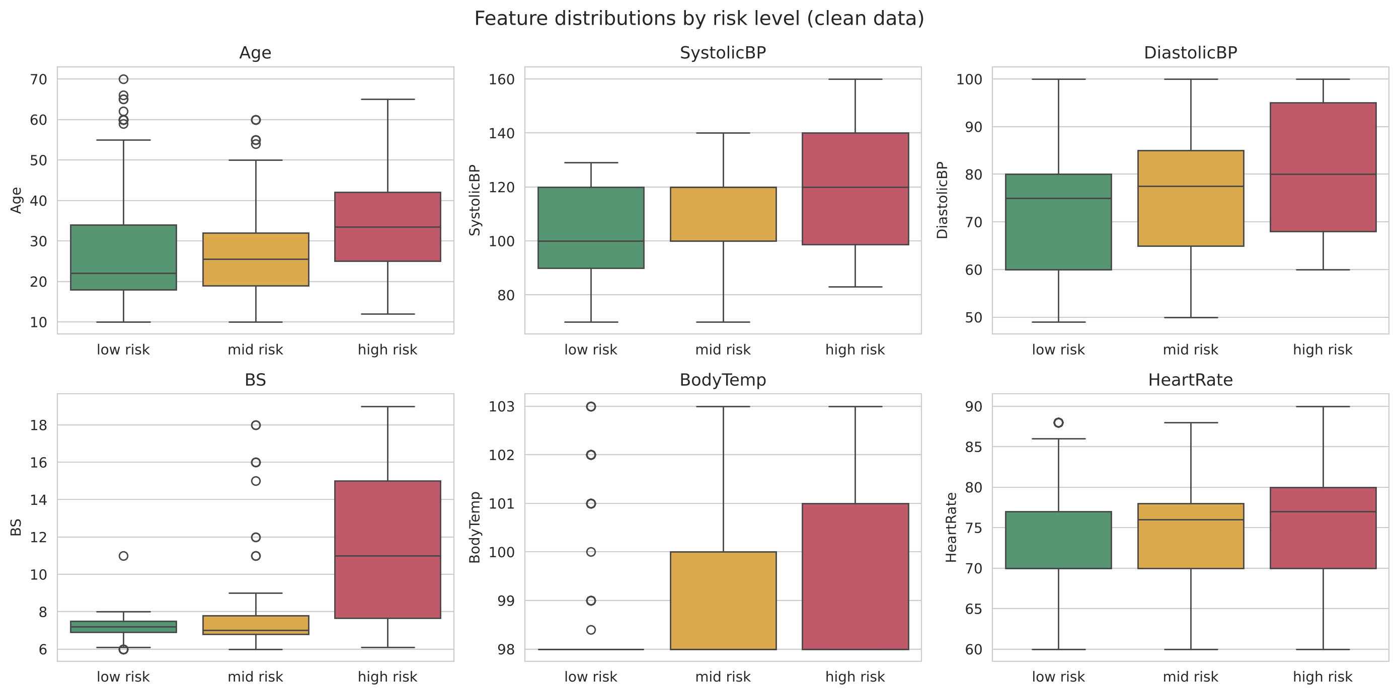
Figure 1: Feature distributions by risk level (clean data)

2.2 Models and accuracy across the three splits
Random Forest (Breiman, 2001) uses multiple decision trees, learns non-linear dependencies without scaling and gives feature importances; however, deep trees can suffer from overfitting. SVM with RBF kernel (Cortes and Vapnik, 1995) maximises margins between classes and performs well with small datasets; features for SVM were scaled using StandardScaler in a pipeline. Stratified sampling was used to keep 5%, 15% and 25% of samples for test, and 5-fold stratified cross-validation was performed on each training sample set.
Table 2: Accuracy of the default models (RF = Random Forest; SD = standard deviation)
Test size (train/test) | Model | CV mean (SD) | Train | Test
5% (428/23) | RF | 0.643 (0.030) | 0.921 | 0.696
 | SVM | 0.687 (0.026) | 0.736 | 0.696
15% (383/68) | RF | 0.661 (0.044) | 0.924 | 0.706
 | SVM | 0.702 (0.042) | 0.715 | 0.706
25% (338/113) | RF | 0.651 (0.052) | 0.941 | 0.664
 | SVM | 0.675 (0.038) | 0.725 | 0.699

The cross-validation accuracy was consistent across the splits (Table 2, Figure 2): 0.643–0.661 for Random Forest and 0.675–0.702 for SVM, all greater than the majority class accuracy of 0.517. The variation in accuracy for the test set was larger due to its smaller size; for the 5% split, one wrong classification results in four-point change in accuracy. SVM showed greater CV accuracy than Random Forest for each split.
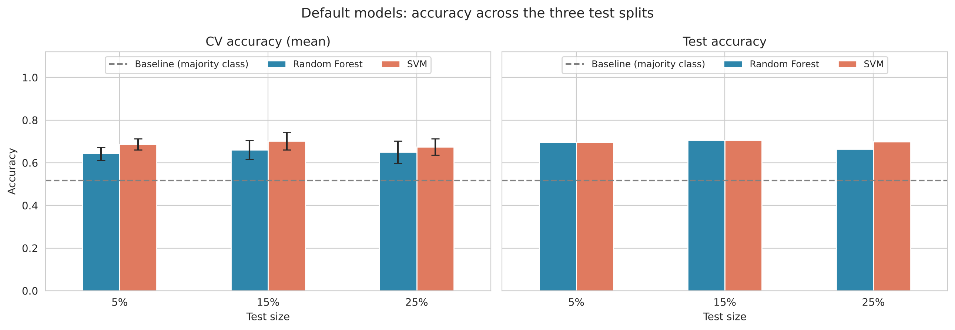
Figure 2: CV and test accuracy of the default models across the three splits

3. Hyperparameter Tuning
The aim of tuning hyperparameters is to obtain the optimal configuration by balancing the overfitting and underfitting problem with respect to unseen data. The process of GridSearchCV involves testing all combinations in a grid using 5-fold CV on the training data set, and it takes the best configuration; hence, no test data set will be used. A 25% split was considered because its test data set of 113 records provides the most accurate estimates. The grid of hyperparameters tested was 27 combinations for random forest (trees, maximum depth, and minimum records per leaf), and 16 for SVM (C and gamma).
Table 3: Default and tuned models on the 25% split
Model | Best parameters | Train | CV | Test
RF default | – | 0.941 | 0.651 | 0.664
RF tuned | max_depth 5, min_samples_leaf 2, n_estimators 200 | 0.769 | 0.716 | 0.770
SVM default | C 1, gamma scale | 0.725 | 0.675 | 0.699
SVM tuned | C 100, gamma 0.01 | 0.719 | 0.684 | 0.690

Reducing the depth of the trees resulted in improvement in the accuracy of Cross-validation of the Random Forest classifier from 0.651 to 0.716 and of the test accuracy from 0.664 to 0.770 (Table 3). The accuracy of CV for SVM increased, whereas the test accuracy decreased from 0.699 to 0.690.

4. Comparison and Interpretation
The unoptimised random forest is overfit: the training accuracy (0.941) is very high compared to the test accuracy (0.664), because the deep trees memorized the training data (see Figure 3). However, after optimising the model, the difference disappeared and indicates excellent generalization. For both SVM models, the difference was small (about 0.03). None of the models suffered from severe underfitting; however, accuracy did not exceed 0.80, which is due to label noise: 71 samples (15.7%) share identical vital signs and risk level.
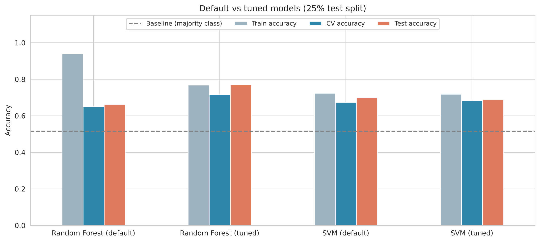
Figure 3: Training, CV and test accuracy of the default and tuned models
Based on Figure 4, it is clear that the fine-tuned Random Forest could identify 23 out of 28 high-risk patients (recall 0.821, precision 0.852), while SVM could only identify 20 out of 28 (recall 0.714). The low-risk class is accurately identified, but most of the mid-risk women are classified into the low-risk category (recall 0.222 for Random Forest) due to the similarity in their values.
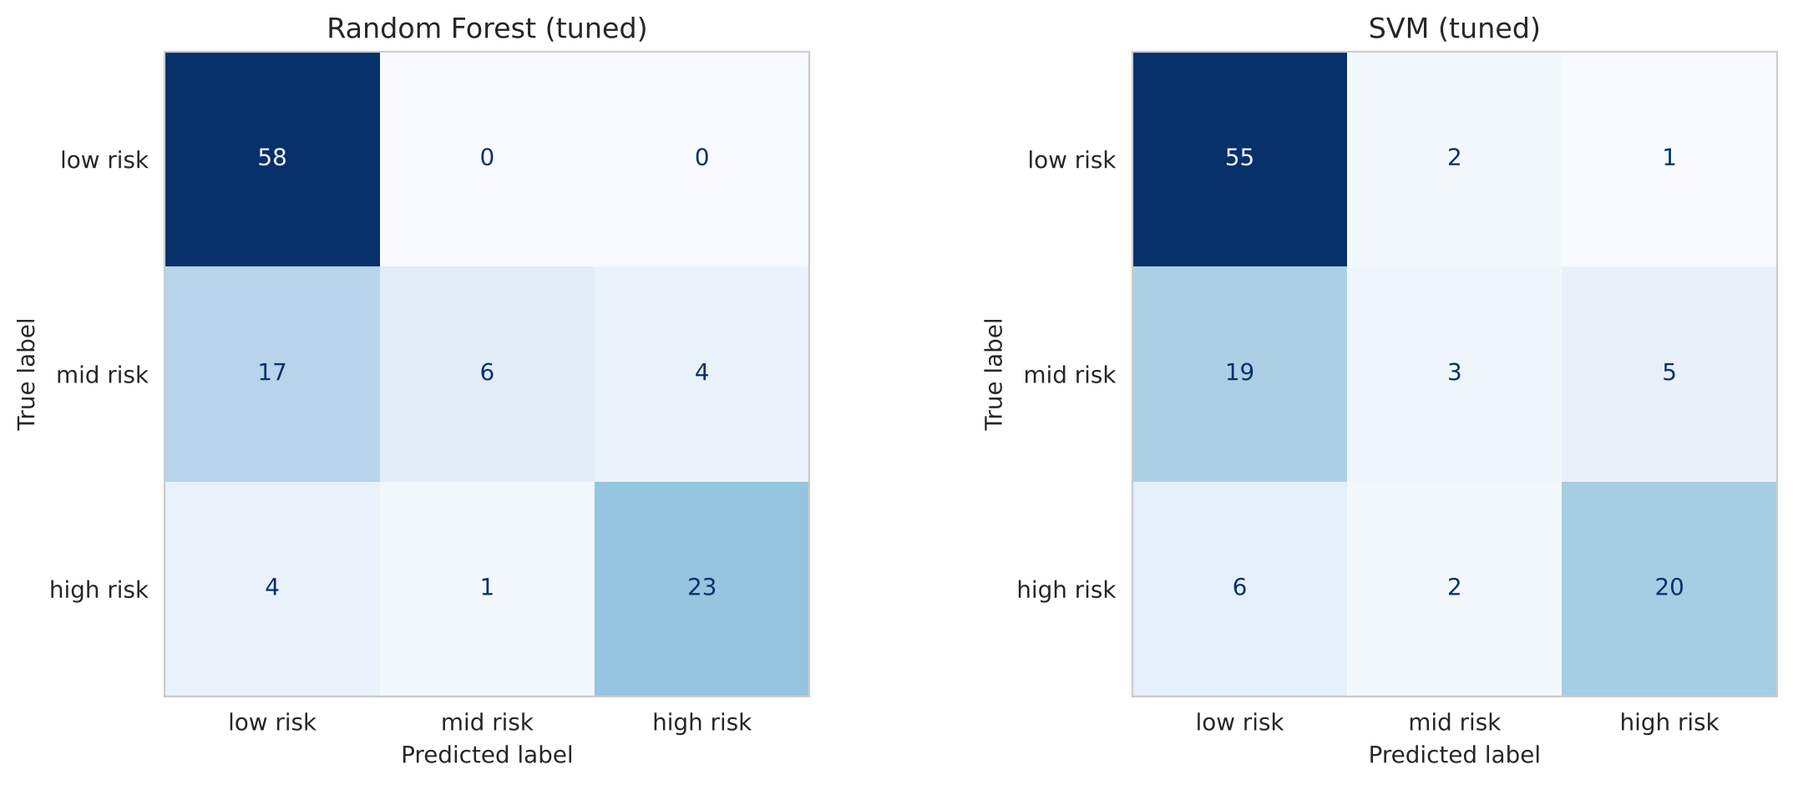
Figure 4: Confusion matrices of the tuned models (25% test set)
Blood Sugar and Systolic Blood Pressure were the most significant features (Figure 5), while removal of Blood Sugar resulted in the maximum decrease in CV score, by 8.6 points. This is consistent with the statistical test results and also with medical knowledge, where high blood sugar levels correlate with gestational diabetes, while high blood pressure with pre-eclampsia, one of the leading causes of maternal mortality (WHO, 2025).
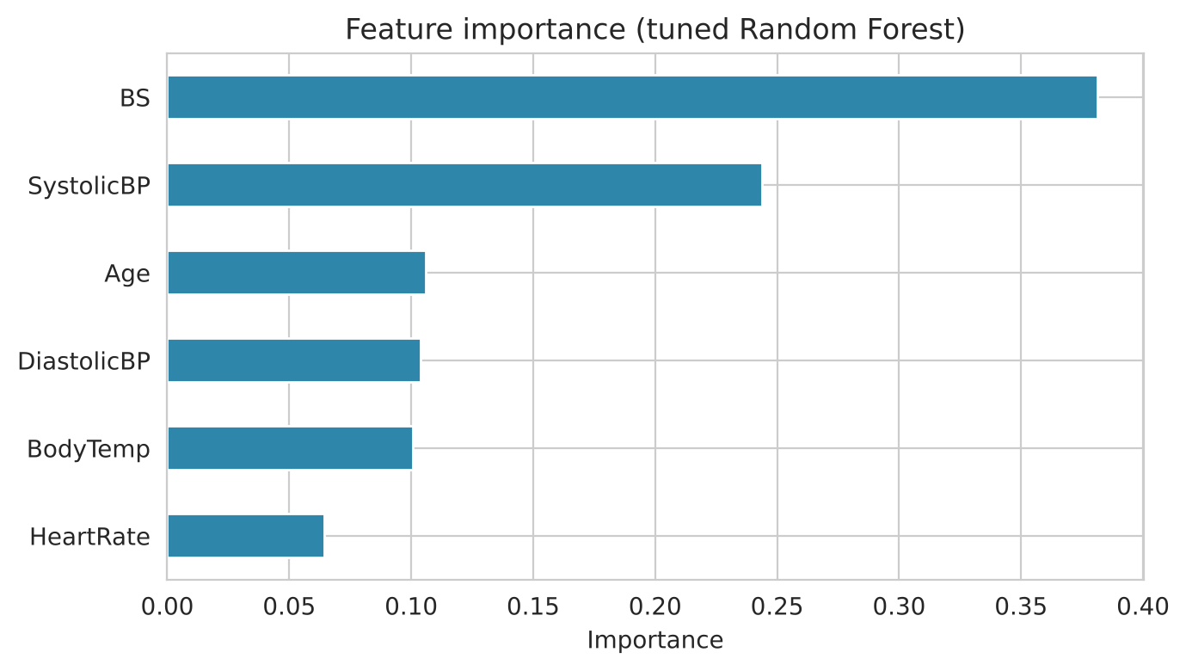
Figure 5: Feature importance of the tuned Random Forest

5. Conclusion
The optimized Random Forest is the optimal model since it performed better in terms of CV (0.716) and test (0.770) accuracies, had no overfitting problem after optimization and provided the highest accuracy in the detection of high-risk pregnancies. SVM can be considered as an alternative model because it provides quite stable results even without any optimization. In simple terms, the notebook presents the way of deployment of the final model that allows predicting the risk level of a patient. Blood sugar and systolic blood pressure were the strongest predictors, while the results of CV were stable in all cases. The major drawbacks are a small one-region dataset and noisy labels with poor mid-risk classification.

References
Ahmed, M. (2020) Maternal Health Risk [Dataset]. UCI Machine Learning Repository. Available at: https://doi.org/10.24432/C5DP5D (Accessed: 9 November 2026).
Ahmed, M., Kashem, M.A., Rahman, M. and Khatun, S. (2020) 'Review and analysis of risk factor of maternal health in remote area using the Internet of Things (IoT)', in Kasruddin Nasir, A.N. et al. (eds) InECCE2019: Proceedings of the 5th International Conference on Electrical, Control & Computer Engineering. Lecture Notes in Electrical Engineering, vol. 632. Singapore: Springer, pp. 357–365.
Breiman, L. (2001) 'Random forests', Machine Learning, 45(1), pp. 5–32.
Cortes, C. and Vapnik, V. (1995) 'Support-vector networks', Machine Learning, 20(3), pp. 273–297.
Kaufman, S., Rosset, S., Perlich, C. and Stitelman, O. (2012) 'Leakage in data mining: formulation, detection, and avoidance', ACM Transactions on Knowledge Discovery from Data, 6(4), Article 15. Available at: https://doi.org/10.1145/2382577.2382579.
Kruskal, W.H. and Wallis, W.A. (1952) 'Use of ranks in one-criterion variance analysis', Journal of the American Statistical Association, 47(260), pp. 583–621.
Larose, D.T. and Larose, C.D. (2014) Discovering Knowledge in Data: An Introduction to Data Mining. 2nd edn. Hoboken, NJ: John Wiley & Sons.
Pedregosa, F. et al. (2011) 'Scikit-learn: machine learning in Python', Journal of Machine Learning Research, 12, pp. 2825–2830.
World Health Organization (2025) Maternal mortality. Available at: https://www.who.int/news-room/fact-sheets/detail/maternal-mortality (Accessed: 9 November 2026).

